**MICHAEL OLAMIDE OGUNYEMI**

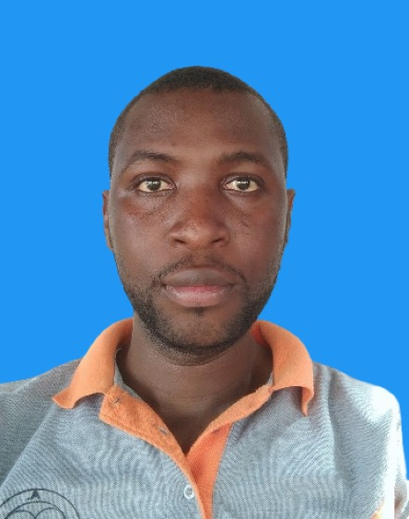

4 Al Yanboo Street, off Al Mansoura, Doha. Qatar.

**+97433955138 |** [**mideyemi86@gmail.com.**](mailto:mideyemi86@gmail.com.|) **|**[**https://www.linkedin.com/in/mideyemi**](https://www.linkedin.com/in/mideyemi)

**QID: 29056600502**

**POST SECONDARY EDUCATION**

**Tai Solarin University of Education, Ogun State 2008 – 2012**

**BSc.Ed** Computer Science Education

**Thesis**: “Computer Network Techniques”

**Major GPA**: 5.0/5.0 **Final cumulative CGPA**: 3.71/5.0 **Second Class Upper Division**

**RELEVANT WORK EXPERIENCE**

* **Contactopia, Sharjah, UAE (BPO Phillip Electronics, ME) November 2021 – Sept. 2023**

**Position: Customer Service Representative.**

* + Respond to Customer Inquiries: Address customer inquiries and concerns promptly and accurately, ensuring all emails are answered within the company's designated response time.
  + Provide Product Information: Familiarize oneself with the product line and be able to provide detailed information about the features, functionalities, and specifications of Phillip Electronics products.
  + Troubleshoot Issues: Assist customers in resolving technical issues and provide troubleshooting guidance for problems related to the use of Phillip Electronics products, either by offering solutions directly or by coordinating with the appropriate technical support team.
  + Handle Returns and Exchanges: Process return and exchange requests, following the company's guidelines and policies, and ensure that customers receive the necessary support to complete the return or exchange process smoothly.
  + Resolve Complaints: Handle customer complaints with patience and professionalism, aiming to find satisfactory solutions that meet both the customer's needs and the company's policies.
  + Maintain Customer Records: Keep detailed records of customer interactions, inquiries, complaints, and resolutions in the company's database to ensure a comprehensive understanding of each customer's history and needs.
  + Collaborate with Other Teams: Coordinate with other departments, such as sales, technical support, and logistics, to ensure a seamless customer experience and to address any complex or specialized customer queries.
* **MTN Nigeria.(Equinox Int. Concept)** **November 2017 – Sept. 2021**

**Position: Customer Service Representative.**

* Respond promptly to customer inquiries via phone in a professional and courteous manner.
* Provide accurate information about MTN Nigeria's products, services, and promotions to customers.
* Resolve customer complaints and issues effectively, aiming for first-call resolution to enhance customer satisfaction.
* Document all customer interactions and transactions accurately in the company's CRM system.
* Collaborate with other departments to ensure prompt resolution of complex customer issues.
* Identify and escalate priority issues to the appropriate department for further assistance.
* Maintain a comprehensive understanding of MTN Nigeria's policies and procedures.
* **Techmanhindra Nig (Airtel BPO).**  **Mar. 2014 – Oct. 2017**

**Position: Call Centre Associate.**

* Responded to inbound customer inquiries and issues via telephone calls, demonstrating a strong understanding of Airtel's products and services.
* Handled a high volume of calls and maintained a professional and courteous demeanor at all times, ensuring a positive customer experience.
* Assisted customers with billing inquiries, service cancellations, technical troubleshooting, and general product information, consistently achieving high levels of customer satisfaction.
* Utilized company systems and databases to accurately document customer interactions, update customer information, and resolve issues in a timely manner.
* Collaborated effectively with team members and other departments to resolve complex customer issues, contributing to a cohesive and supportive work environment.
* Participated in ongoing training and development programs to enhance product knowledge and improve customer service skills, contributing to the overall performance of the call center.
* Met and exceeded individual and team performance targets, including average call handling time, customer satisfaction ratings, and resolution rates, as set by Airtel Nigeria's management.

**OTHER WORK EXPERIENCE**

* *HR Team Member*, **Evertop Global Resources (Edu-travel services)** Nov. 2020 – Jun. 2022.
* *Subject Teacher (NYSC),* **Government Secondary School, Keffi, Nasarawa.** Mar. 2013 – Feb 2014

**LEADERSHIP EXPERIENCE**

* **Project Group Coordinator:** **April 2012**

I worked as a liaison officer between the project group members and the Supervisor in charge.

* **Class Head Of Course:** **2008-2012**

I served as a middleman between the students/department and the school management on student related issues such as assignment submission, rectifying exams/result complain, organizing academic field trips, attending departmental meetings for drafting of lecturers and exam timetables.

**PERSONAL SKILLS**

* Excellent verbal and written communication skills in English.
* Proficient in using customer service software and CRM systems.
* Ability to handle a high volume of customer inquiries and maintain a positive attitude.
* Strong problem-solving and conflict resolution abilities.
* Familiarity with MTN Nigeria's products, services, and telecommunications industry.

**ICT SKILLS**

Tune-Up Utilities, Microsoft Virtual Machine, Microsoft Security Essential Antivirus, Microsoft Office Suite 2003, Microsoft Office Suite 2007, Microsoft Office Suite 2010, WordPress, MySQL, TABS, MINSAT, SINGLEVIEW.

**LANGUAGE(S) SPOKEN**

Fluent in English: My home country’s official language and mode of instructions from elementary school.

Fluent in Yoruba: Mother’s tongue.